Title. Subtitle [Style: JLAR Title]

* [Link icon to OrcID]Carberry, Josiah1 **[Style: JLAR Authors]**
* **SecondAuthorName, SecondAuthorGivenName**

**1**Brown University, Providence, RI (USA) [Style: JLAR Info]  
Correspondence/corresponding author: [carberry@mailinator.com](mailto:carberry@mailinator.com)

Abstract [English, 300 words] **[Style: JLAR Heading 1]**

The use of smartphones […] [Style: JLAR Abstract]

**Keywords**: interpersonal communication, communicative action, mobile phone, norm [Style: JLAR Info]

Abstract [other language, 300 words, not mandatory]

You are invited to provide the translation of your abstract into the target language, or in any language that is relevant with regard to the audience. This second abstract is not mandatory. Style: JLAR Abstract

**Keywords**: interpersonelle Kommunikation, kommunikatives Handeln, Mobiltelefon, Norm [Style: JLAR Info]

**Journal article** reviewed [Style: JLAR Info]

**Submitted:** dd month yyyy [Style: JLAR Info]  
**Accepted:** dd month yyyy  
**Publiziert:** dd month yyyy

* This article is licensed under the [Creative Commons Attribution Licence 4.0](https://creativecommons.org/licenses/by/4.0/) [Style: JLAR Copyright]  
  © Author name

1 Introduction **[Style: JLAR Heading 1]**

Introduction to your paper. Please do not manually format the text with hard formatting, but assign the formatting offered under “Home–Styles” to any letters and paragraphs [Style: JLAR Body text].

1.1 Special characters

Please make sure that you use Unicode for any special characters. If unicode fonts are not available, please contact the editors.

1.2 Block quote

Short quotations can be included in the body of the text.

Quotations of more than three lines should be formatted as block quote [Style: JLAR Quotation]. Quotations will be automatically formatted with left indentation.

1.1 Lists

For a lists, please use the appropriate style.

* First element in the list.
* Second element in the list.
* Third element in the list.

2 Outline

2.1 Examples [Style: JLAR Heading 2]

Please apply linguistic standards for quoting examples ‘with translation’ in simple quotation marks.

Please follow the guidelines of ###Leipzig glossing rules, if applicable.

1. Example in italics [Style for this paragraph: JLAR example; style for characters: emphasis]  
   glossing [Style for this paragraph: style for characters: Small caps]  
   ‘Translation’

2.2 References

Please follow the ###Chicago guidelines for references.

2.3 Tables and figures

1. Title of the table [Style: JLAR Table heading]

| First | Second **[Style: JLAR Column title]** | Third |
| --- | --- | --- |
| Numbers right aligned | 125 |  |
| **[Style: JLAR Table content]** | 30 |  |
|  |  |  |
|  |  |  |

Please make sure that complete copyright information is provided. Figures should come with 300 dpi.

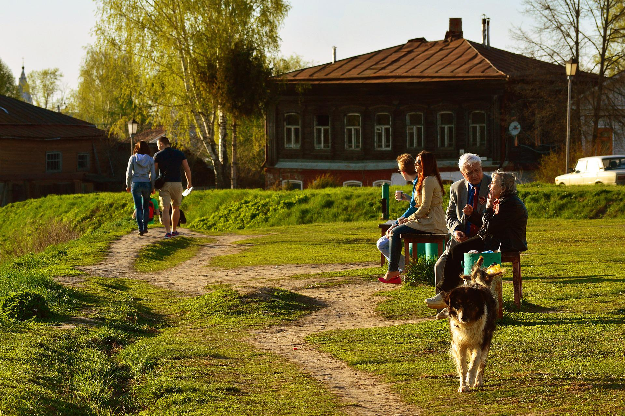

1. Leisure (Pixabay islandworks)

2.3.1 Headings

Please check if you need more than two levels of headings, and if there are single instances of headings, e.g., only one paragraph on the third level.

3 Discussion

Please make sure that any numbered element is referenced to in the body of the text, Figures (**Error! Reference source not found.**) as well as Tables (Table 1) and examples (1).[1]

4 Conclusion

Thank you for publishing with JLAR.

Declarations

Authors contributions

If applicable, please assign the chapters to their individual authors.

Conflict of interest

Please provide information on any possible conflict of interest, otherwise state “NA”.

Data availability

JLAR supports ###FAIR principles. As far as possible, please make data, coding and annotations available.

Credits and funding

Please provide complete information on funding, if not applicable, state “NA”.

Ethical standards

Please carefully read our ethical guidelines ###LINK and make a statement according to them.

References

Please provide a bibTex or *.ris formatted file with the complete list of references with the final version of your paper. It will be used to create a list of your references according to Chicago Manual of Style Chicago Manual [Style: JLAR Bibliography].

FAIR principles

Language Science Press?

Leipzig Glossing Rules

Endnotes

1. Please use “References-CrossReference-NumberedElement-[Figure|Table|Example]”.